**Salzburg Institute Summer Program - Website Updates**

**Global Changes (check all new student application and accepted student application pages)** **(Done)**

All bullets need to be 1px smaller font than default paragraph text and in normal bullet format. Normal bullet format means the word wrap aligns to the right of the bullet. For example:

**Application Information Page (Done)**

1. Under Eligibility – fix bullet formatting
2. Under Included Program Costs: fix bullet formatting

**Application Form Page (Done)**

The type of box under the Statement by Applicants section needs to be removed. It should not be a field box – that is too large. Replace it with two text boxes:

Full Name Date

**Application Uploads Page (Done but functionality for email is remaining)**

Under Letters of Recommendation please add another set of fields so the student can send requests to 2 different referees

Name of Referee Email Address

Note: this form is not working. I entered my email address expecting to get the email and it never came. Please test this by entering your email and then when you get the email click the link and make sure you can complete the recommendation form.

Also we need to set up each of the file uploads so they come from one form. If you upload files now you will notice having submit button for each upload is messing things up.

**Payment Page (Done)**

Under Payment Timeline and Withdrawal Terms, please copy tables from the Application Page so that it they identical.

**Accepted Students Section (Done)**

Fix bullet formatting

For the check box section, add a space after the check boxes

This map was left off the site. Please add it to the end of the document.

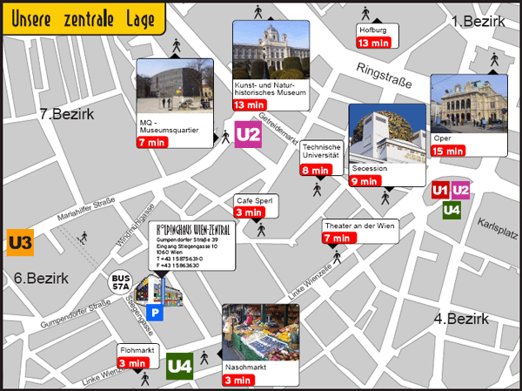

When a student clicks the Apply button they will go to the Applications Information page but please keep the banner image that is showing on the Apply page now. That image is only needed for the Application Information page. We can add one drop down for Accepted Students and that take users to the Accepted Student section